**Big data Analytics**

# **CS5590BD**

**Lab-3 Assignment**

BY

L V SANDEEP, BATHINA (16174348)

Task1: Application on sensor tag

* **Subtask1 :  Implement an application to generate a file for below activities**

**Steps:**

1. Import and Run the given application by doing some slight modifications in the code.

This code runs for following activities:

1. Accelerometer
2. Geo Location
3. Data
4. Run the application on Nexus phone as follows.

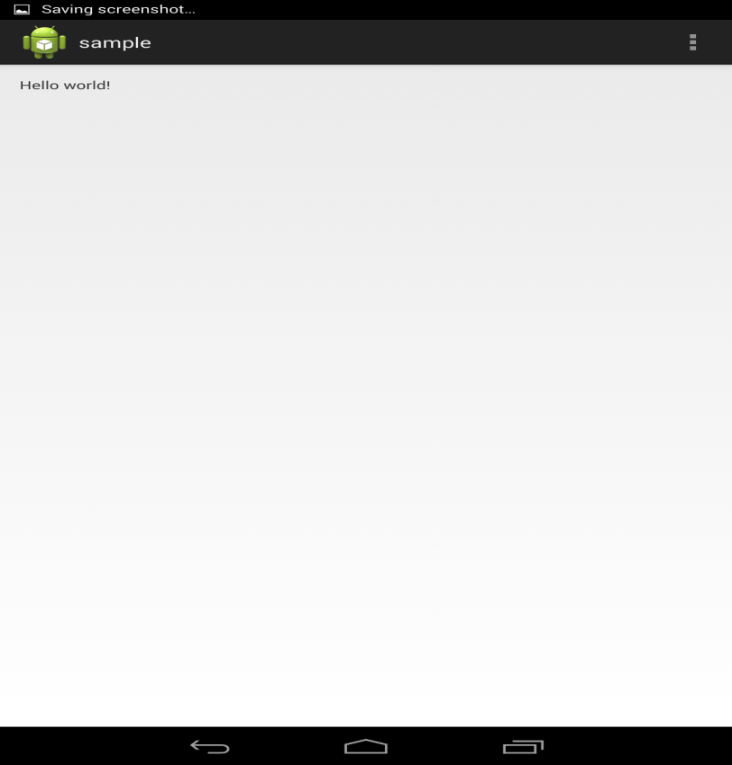

1. The file generated in the phone is sensor_group6.txt as follows in Astro file manager:

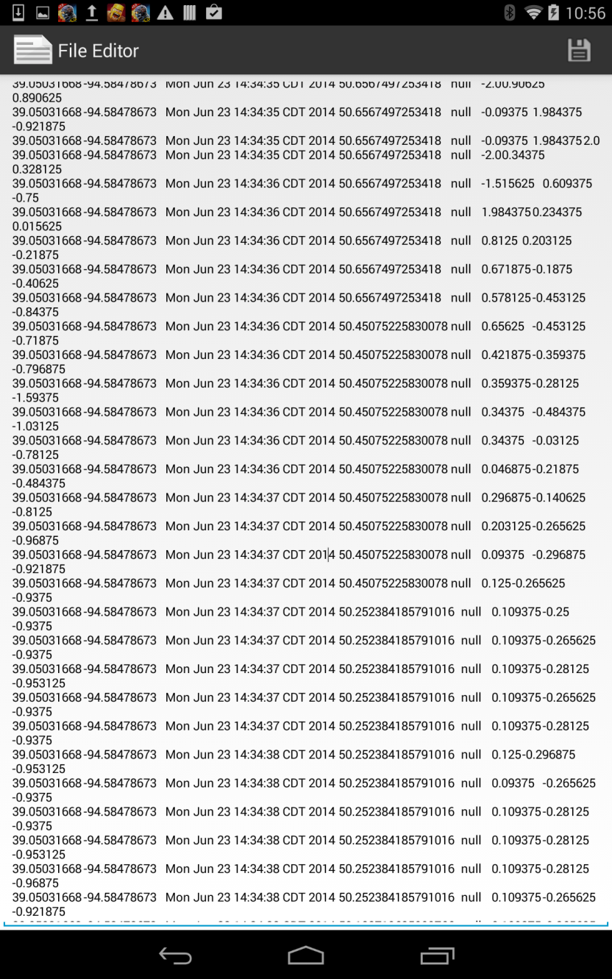

1. Generated file content is:

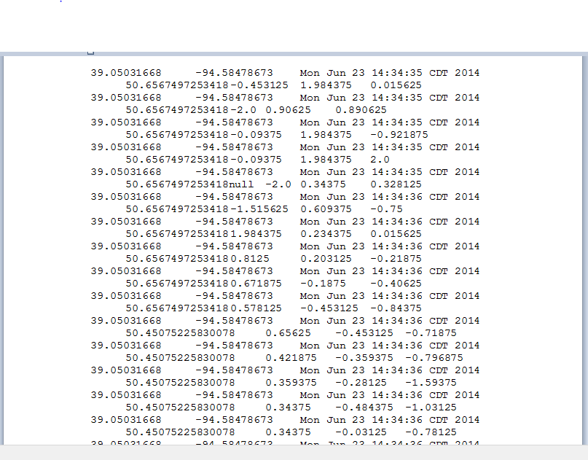

Task 2: FILE TRANSFER

* **Subtask 1: Develop an application to perform File Transfer operation from local machine to cloudera.**

**Steps:**

1. In order to Transfer file, add the below code.

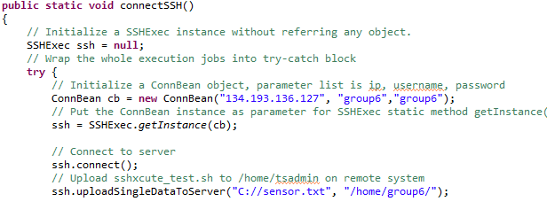

1. Now run the application and the output displayed will be showing that file transferred successfully.

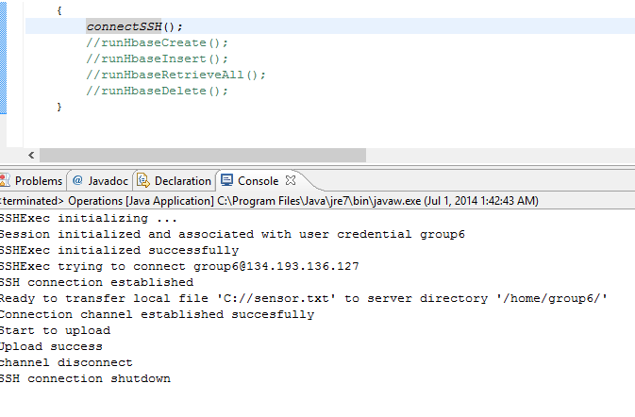

1. 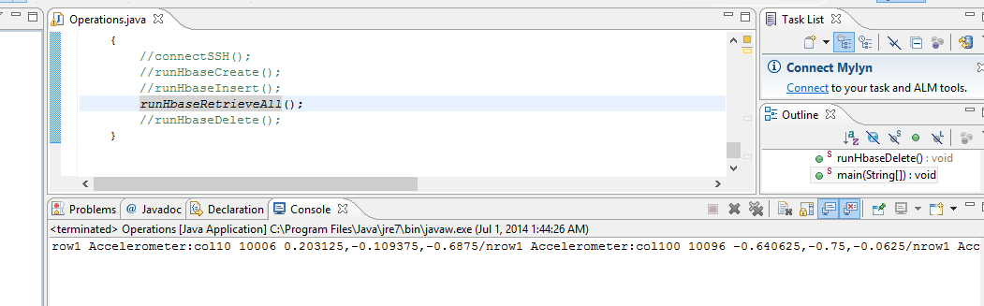We can perform crud operations over here.

TASK 3:  HBase CRUD operations

* **Subtask 1:  Implement an android application to perform CRUD operations on HBASE for the generated file.**

**Steps:**

1. Design User Interface as below:

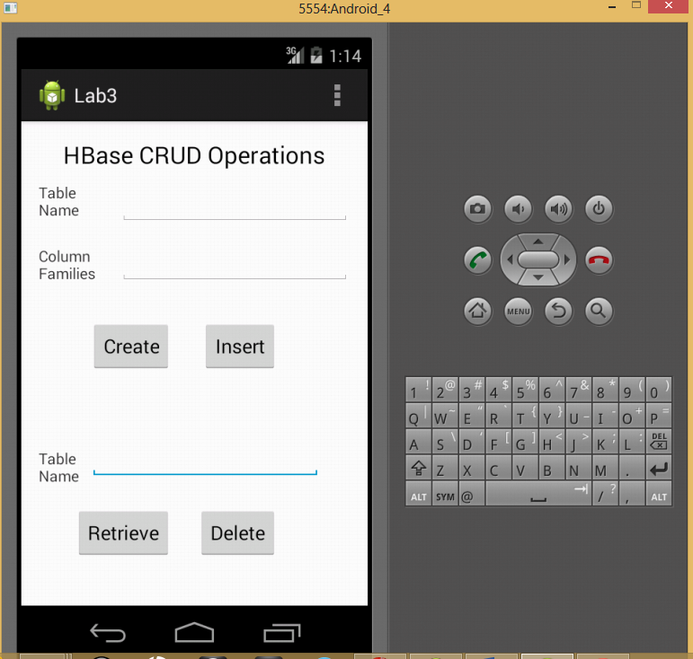

1. Now Type Table name and column names for that table and click on crate to create the table in HBASE

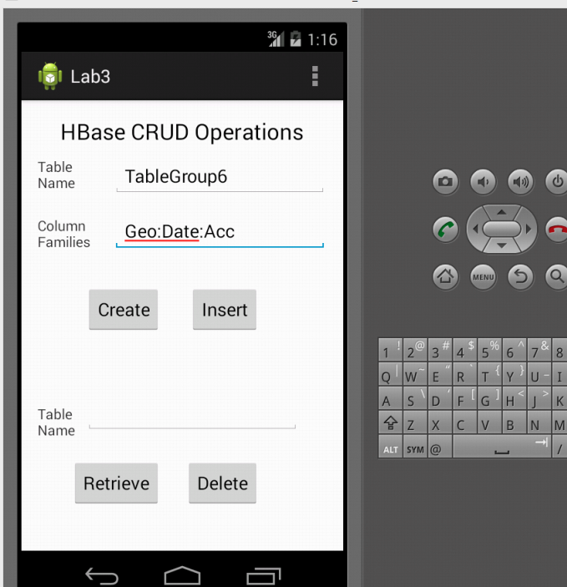

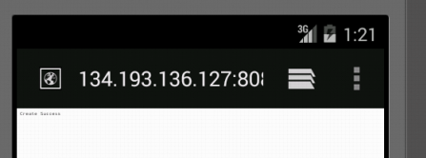

Similarly follow the same procedure to insert the file present at C://sensor.txt.

1. To Retrieve the contents of table, type table name and hit the retrieve button.

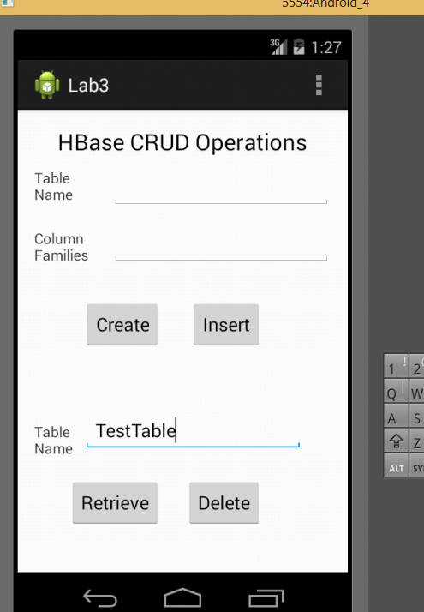

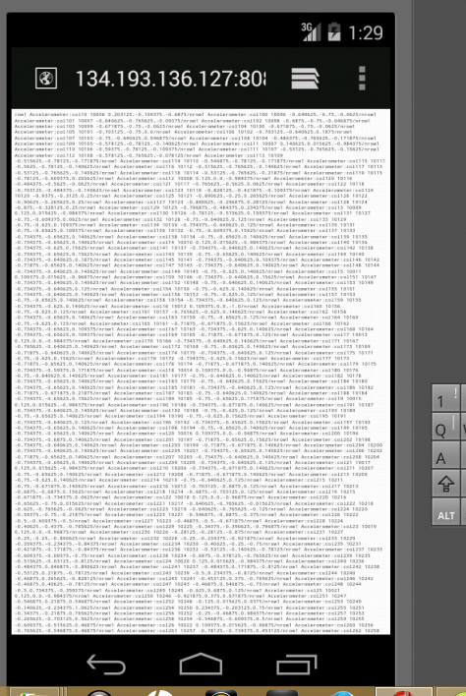

Similarly follow the same procedure if you want to delete the table from HBASE.